Fungi

Fungi are either single celled or in filaments and have a cell wall of chitin. Fungi are heterotrophic – they cannot make their own food.

Saprophytic fungi such as Rhizopus feed on dead organic matter.
Parasitic fungi such as the potato blight fungus live with and feed off another living organism causing it harm.
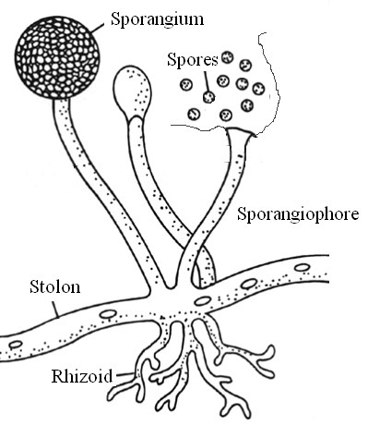
Rhizopus

Rhizopus is composed of hypha which are tubular filaments A collection of hypha is called a mycelium. Horizontal hyphae are called stolons, they grow along the food surface.
Rhizoids grow down into the solid food anchoring the fungus.
Sporangiophores grow upwards and carry spore filled structures called sporangia. These spores are released for wind dispersal. The spores are separated from the sporangiophore by the columella.

Nutrition
Hyphae secrete digestive enzymes into the external environment so that food is chemically broken down outside the fungus. The simple soluble products are absorbed into the hyphae by diffusion and active transport.

Reproduction
Rhizopus reproduces asexually when wind dispersed haploid spores divide by mitosis into a new filament. Sexual reproduction occurs when 2 strains ‘plus’ and ‘minus’ are close. Hyphae of opposite strain grow towards each other. The touching tips of the hyphae swell and form 2 gametangia The contents of the gametangia fuse.
The combined gametangia develop into a diploid zygospore. The zygospore is thick-walled resistant and dormant. In favourable conditions the zygospore germinates by meiosis. A haploid sporangiophore with a spore-filled sporangium grows from the zygospore. The spores are wind dispersed and germinate forming a new haploid mycelim.
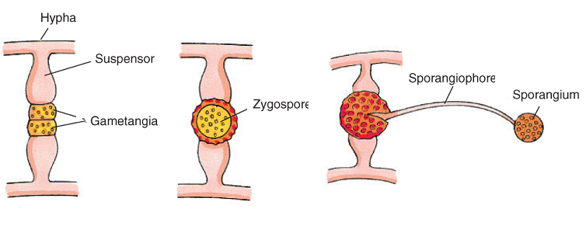
Yeast
Yeast is a single celled fungus strains of which are used in brewing and baking. Some strains of yeast such as thrush c.albicans are pathogens.

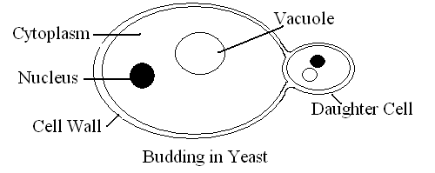Reproduction
Yeast can reproduce very quickly by budding a form of asexual reproduction. A small bubble-like extension grows from the cell.
The nucleus undergoes mitosis and a daughter nucleus moves into the bud. The bud may remain attached and form a small colony by further budding or can separate completely.
Economic Importance of Fungi

Beneficial | Harmful
Alcohol (ethanol) formation for beer and wine | Crop diseases, e.g., potato blight
Carbon dioxide gas formation for baking | Food spoilage
edible fungi | Poisonous mushrooms (Death Cap)

INVESTIGATE THE GROWTH OF LEAF YEAST USING AGAR PLATES AND CONTROLS

- Swab the laboratory bench with disinfectant.
- 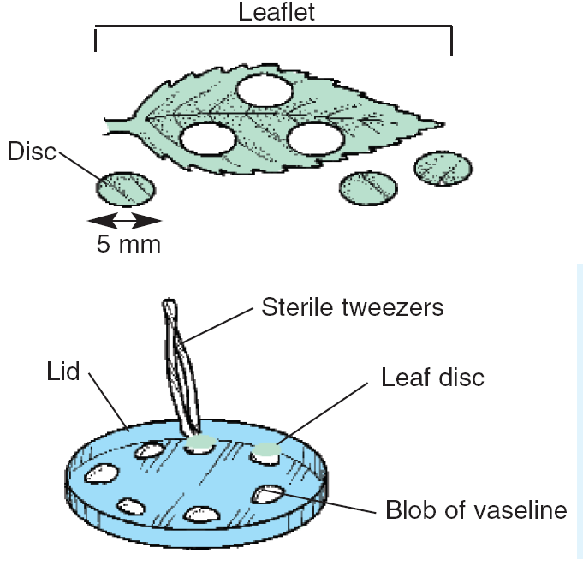Seal one sterile malt agar plate and label as ‘control’.
- Sterilise the cork borer and cut five discs from the leaves.
- Using a sterile forceps, smear five small amounts of petroleum jelly on the inside of the petri dish lid.
- Sterilise the forceps again and attach a leaf disc to each of the blobs of petroleum jelly.
- Replace the lid onto the agar-containing base of the plate
- Leave the plates upright for approximately 24 hours so that spores can drop onto the agar from the leaf discs.
- Invert the plates and incubate both plates (experiment and control) upside down, at 18 °C for 3 days.
- Compare the experiment plate with the control plate.
- Record the result. Leaf yeasts will grow as pink glistening colonies.

